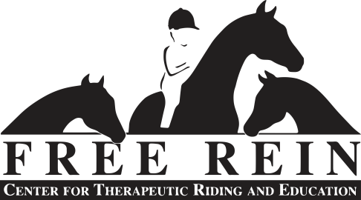

**2025 POLICIES & PROCEDURES**

PAPERWORK

The following paperwork must be complete and submitted to the Program Director one week prior to the beginning of the session for the student to participate. If the student has not submitted complete paperwork by the start of the first lesson, their spot will be opened to those on the waiting list.

* Student Information Packet – New Students Only
* Waiver and Release (2) – Free Rein Center & Rockbrook Camp – New Students Only
* Financial Aid Application (for those requesting aid)
* Policies and Procedures (this form)
* Outcomes & Goals* - To be completed in consultation with instructor during Orientation

*\* To be completed for each session (spring one and two and fall one and two), otherwise paperwork is to be submitted annually.*

ORIENTATION

Orientation meetings will be held at Free Rein at the usual lesson time, the week before lessons begin, unless otherwise agreed to by the instructor or Program Director. There is no lesson fee for the orientation.

|  |  |  |
| --- | --- | --- |
| **Spring One 2025** | **Spring Two 2025** | |
| Mon. Feb. 17 -Fri. March 28 | Mon. Apr. 7-Fri. May 2 | |
|  |  | |
| **Fall One 2025** | **Fall Two 2025** |
| TBD | TBD |

**New students** will meet with their instructor the week before lessons start to receive a tour of the facility, get acquainted with the instructor, discuss Free Rein procedures and student needs, and establish goals.

**Returning students** will meet with their instructors the week before lessons to get reacquainted with the instructor and facility, go over prior session progress, and establish goals for the coming session.

ATTENDANCE

We expect regular attendance during the 8 weeks, as we employ instructors and arrange volunteers for your scheduled lesson time. Failure to appear without notice for two consecutive lessons will result in termination of the session.

Cancellations must be made 24 hours in advance, or 50% of the lesson fee will be due. You must cancel by calling/ leaving a message on the office phone (828)883-3375, although an additional email to the Program Director (programdirector@freereincenter.com) is encouraged.

ATTIRE

Wear protective, yet comfortable clothing- no flapping shirts or open toed shoes or sandals. For mounted students it is recommended to wear long pants and boots that have 1 to 1 ½ inch heal, to ensure safety and comfort while riding. No dangling jewelry allowed, as this may get caught on tack. Remember sunscreen as you can be out in the sun- also bug spray, and water or a cold drink, as we have no running water at the stable.

PAYMENT

Payment is due upon arrival at the lesson. A late fee of $5 will be charged for any payments not made within 7 days of the lesson.

**Payment responsible party**

**Name __________________________________________**

**Address __________________________________________**

**__________________________________________**

FINANCIAL AID

Free Rein’s goal is to be able to make therapeutic riding services available to all participants whose application is accepted, and we are able to do this because of the generosity of our supporters, volunteers, and an intentional fundraising program.

Financial aid awards will be based upon both the applicants’ need and the amount of funds available for the year. Consistent communication and attendance is required to continue to receive financial aid support throughout the year. All requested documents must be complete and submitted before financial aid will be considered. Students and/or the individual(s) responsible for payment are notified by email within 1 week of award status.

STEPS TO APPLY FOR FINANCIAL AID

1. Review and sign *2024 Free Rein Policies* form.
2. Fill out *2024 Application for Financial Aid* form.
3. Obtain copy of first page of most recent tax return.
4. Submit policies form, financial aid application and most recent tax return by:

email to programdirector@freereincenter.com,

hard copy delivered to the office, or

mail to P.O. Box 1325, Brevard, NC 28712 (arriving by the due date).

All students are required to either pay at least $15 (if approved for the 70% scholarship)

***I have read and understand the above policies and procedures.***

**Signature of person completing this form _________________________________________**

**Date ____________________**